Rochester Hills Little League
2026 Fall Training & Development Season
Softball Ages 8-13 (based on age cutoff date of 12/31/25)
Baseball Ages 6-14 (based on age cutoff date of 8/31/26)

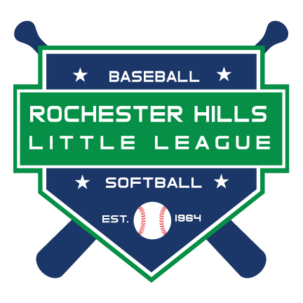

`

Information Packet

RHLL WEB SITE
https://www.rochesterhillslittleleague.com
FALL BALL WEB PAGE
https://www.rochesterhillslittleleague.com/Default.aspx?tabid=2326945

2026 Fall Season and Team Information:

Season Information:

- Managers meeting – TBD
- Pre-Game Practices start around August 1.
- Game Season starts early/mid-August and ends around October 11th. The number of games and practices each team wants is up to them.
- Game scheduling meeting - TBD – start times will vary by division (6pm is the first one
- Games are played on weekends and weeknights. You can practice during the season.
- No games will be played over Labor Day Weekend (Fri-Mon).
- There will be a scheduling meeting for each division which allows managers to get together and determine the dates/times they want to play.
- Managers must register players using the player roster form as a complete team.
- Manager will provide RHLL a roster with individual eligibility information and a medical waiver for each player when registering.

Team Information: BASEBALL

Little League bat restrictions apply for all divisions

Managers will register players as a complete team within one of 4 divisions:
- Rookies– designed for players age 6-8 (Machine pitch)
  - This division is designed for boys planning on playing Rookies in 2027.

- AA – designed for players age 8-9 (7 yr old if they plan to play kid pitch in 2027).
  - This division is designed for boys planning on playing AA division in 2027.

- Majors/AAA – designed for players 11 and under.
  - This division is designed for boys planning on playing Majors or AAA division in 2027. Teams may also play teams from IM division.

- Intermediate - designed for players 14 and under.
  - This division designed for boys planning on playing IM division in 2027. Teams may also schedule games with teams from Majors.

- Managers can register teams to play up (11 year old team can play with 12 year old team as an example) to increase the competition level if desired.
- Ultimately, it is up to the manager to decide what age groups he wants on his team. If he has players that want to play up or down a division per our recommendations, that is fine.

Team Information: SOFTBALL

- Minors – designed for players 10 and under
  - This division is designed for girls planning on playing MNSB division in 2027.

- Majors – designed for players 13 and under.
  - This division is designed for girls planning on playing Majors division in 2027.

- If we are unable to get enough players to have 2 divisions, we can combine the teams into one division and have players with ages ranging from 8-13
- Ultimately, it is up to the manager to decide what age groups he wants on his team. If he has players that want to play up or down a division per our recommendations, that is fine.

Team Fees:
- $1,700.00 which includes jerseys, hats, insurance (if all players live within RHLL Boundaries), game balls, equipment (helmets, catchers gear, bats, etc. if needed). If your team already has its own uniforms and does not want RHLL to provide them, your cost is $1400.
- Umpire fees are $30.00 per team per game for MJBB, MJSB and IM, $25 per team for all other divisions. Fees will be collected before the start of each game.

Individual Fees:
RHLL will allow for players to register individually and we will try to assist in signing the player to a team if possible. Details on how to do that via the web site will follow in early July. Best way to ensure you get on a team is to seek out current teammates, coaches or friends to see if they are playing and are forming a team.

`
Registration Information:

If you are NOT a returning/approved RHLL Manager or Coach from the 2026 Spring Season, you will need to register as a volunteer on RHLL’s web site. Go to Managers page after accessing our site
https://www.rochesterhillslittleleague.com/
From there, RHLL will trigger an email to be sent that will ask you to complete and submit your background check application. No Manager or Coach is permitted to interact/coach a child or be on a field until they have an approved background check. A required Manager’s meeting will be scheduled where we will go over the general ground rules for the season. No team standings will be kept.
Managers are encouraged to provide information on team, intended division of play, rosters via email to
RHLL at RHLLemail@yahoo.com as soon as teams are put together. ROSTER DEADLINE is 7/31/2026

